7-2.HelloBot tracking
1.Preparation
1.You should learn about the position of the RGB tracking obstacle avoidance 3 in 1 module in the body of hellobot；
2.You should learn about the principle of the tracking.
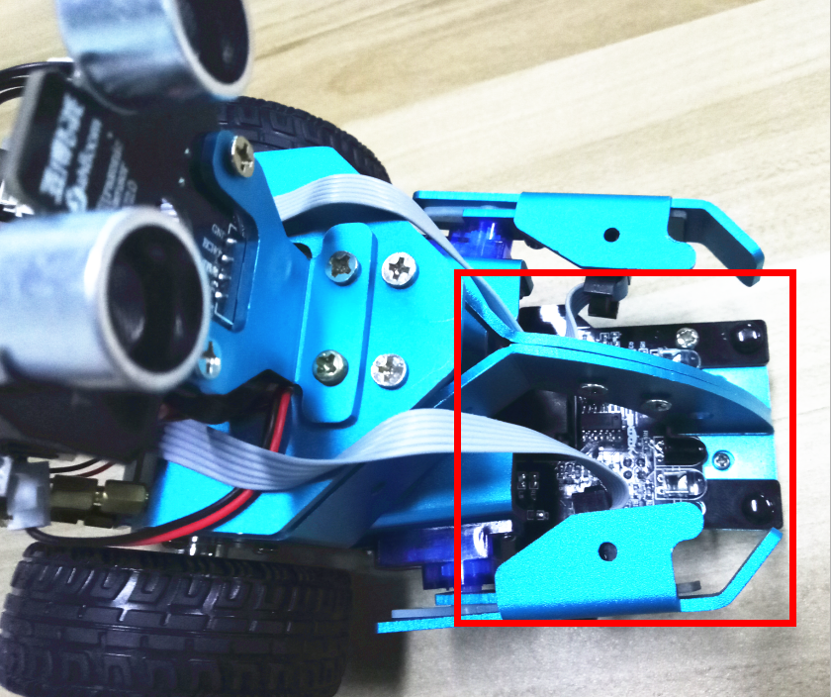
7-2-1 RGB tracking obstacle avoidance 3 in 1 module
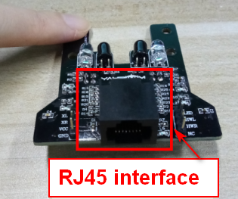
7-2-2 RJ45 interface of RGB tracking obstacle avoidance 3 in 1 module
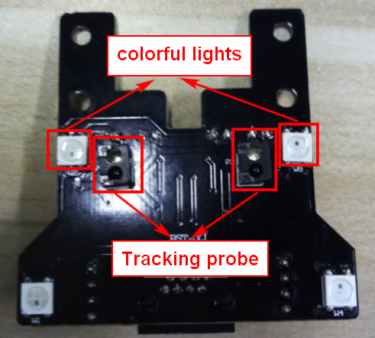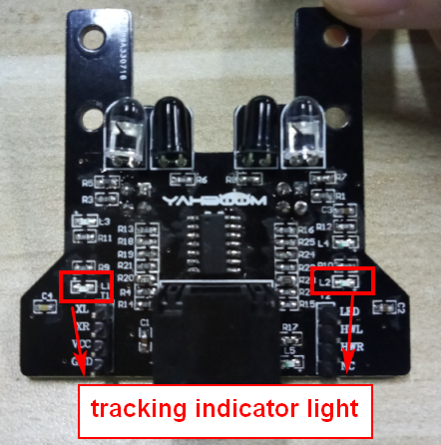
- Back of module (c) Front of module
7-2-3 RGB tracking obstacle avoidance 3 in 1 module
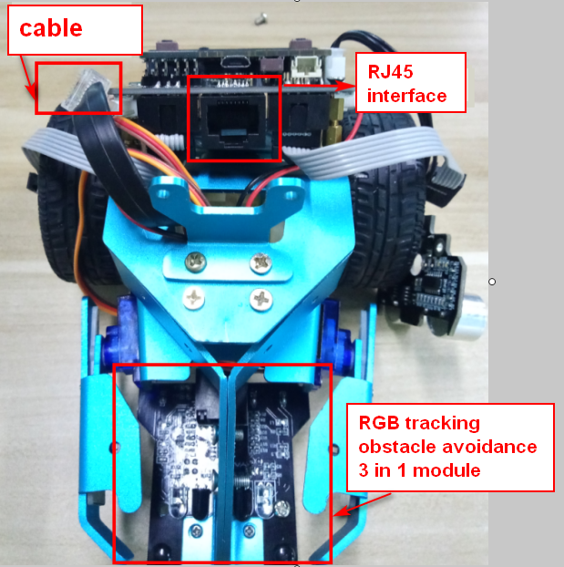
7-2-4 RJ45 interface and cable
The RGB tracking obstacle avoidance 3 in 1 module is installed under the robot arm of the HelloBot, and we need to use the network cable to connect the RGB tracking obstacle avoidance 3 in 1 module.
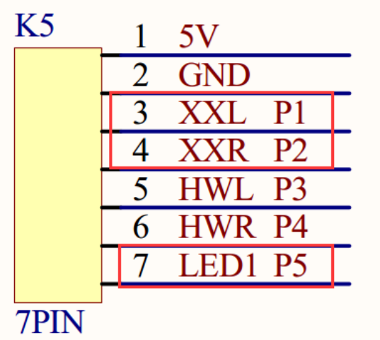
7-2-5 schematic
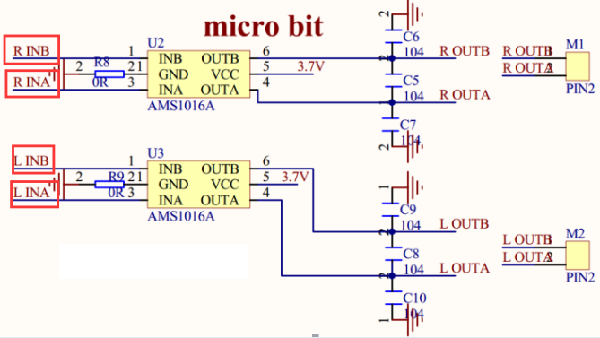
7-2-5 motor drive schematic
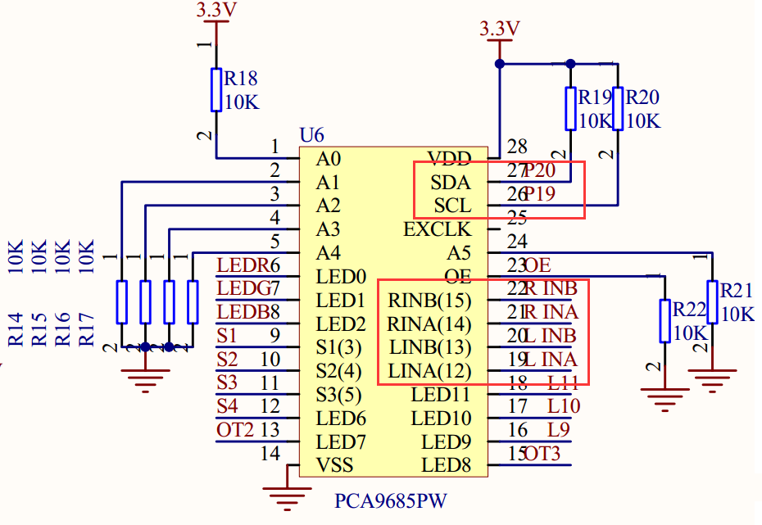
7-2-6 schematic of PCA9685PW

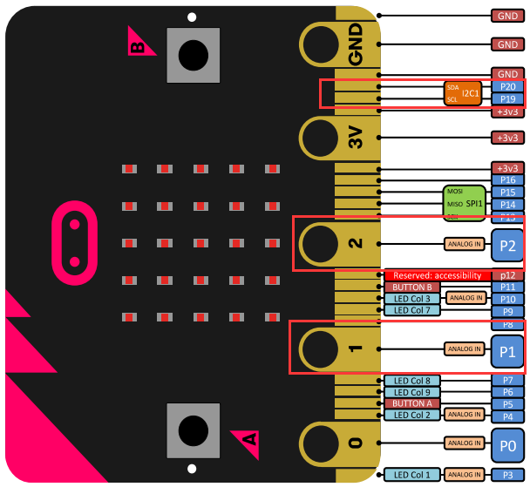
7-2-7 Pins of Micro:bit
From the schematic diagram. You can see that left probe is connected to P1 of Micro:bit, right probe is connected to P1 of Micro:bit, colorful lights is connected to P5 of Micro:bit.
Principle of tracking: The basic principle of the infrared tracking sensor is to take advantage of the reflective nature of the object. When the infrared light is emitted onto the black line, it will be absorbed by the black line, but when the infrared light is emitted onto the other colors line, it will be reflected onto the infrared receiver pin. When the car's tracking module detect the black line, the indicator light is light up, and when the white object was detected, the indicator light is light out.
According to this, we write the corresponding code to make the car complete tracking function.
Note:The tracking sensor is not working properly due to the interference of outdoor light. This course needs to be carried out indoors and the curtains are covered to block the outdoor light.
2.Learning goals
In this experiment, we need the effect that the robot car walk along the black line.
3.Programming
3.1 Programming online
You can enter the URL directly in your browser: http://python.microbit.org/v/1 to enter programming online interface.
3.2 Programming offline
1) You can double-click to use it. As shown in the following figure.

2) After entering the programming interface.
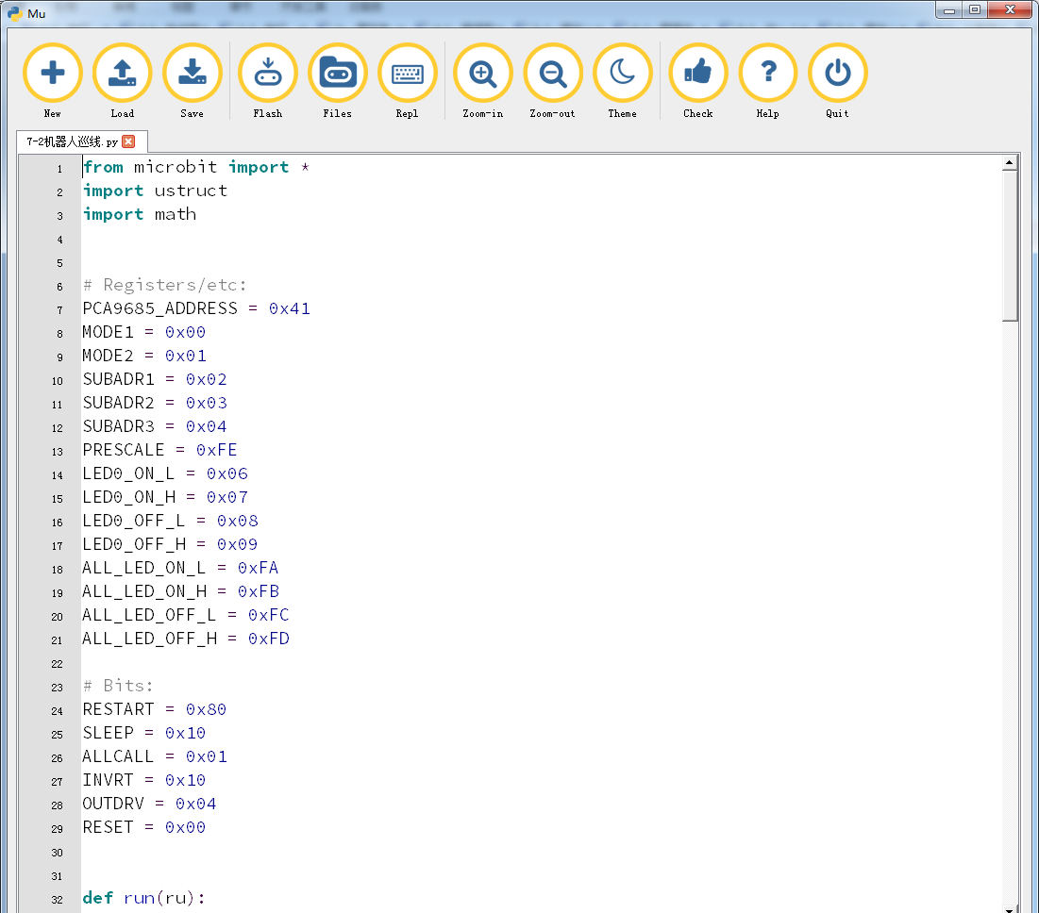
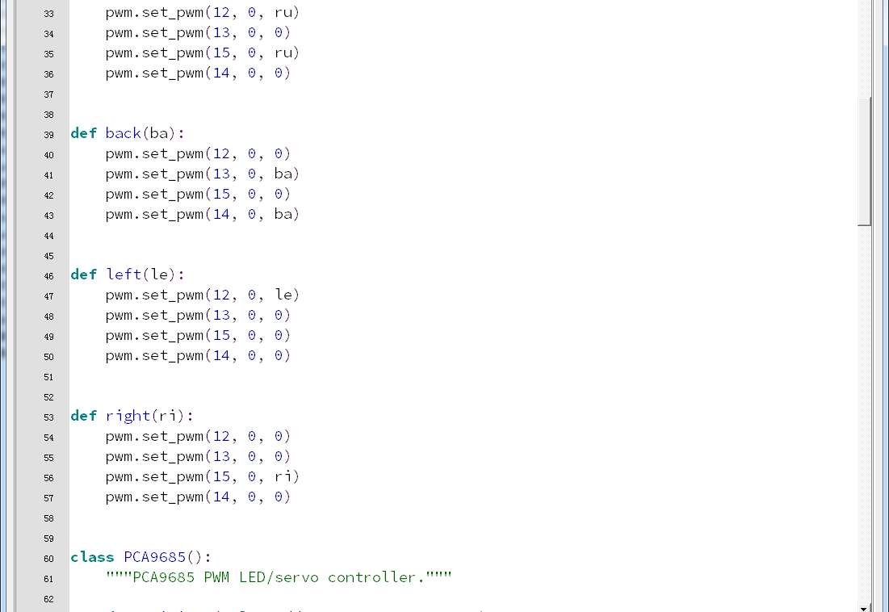
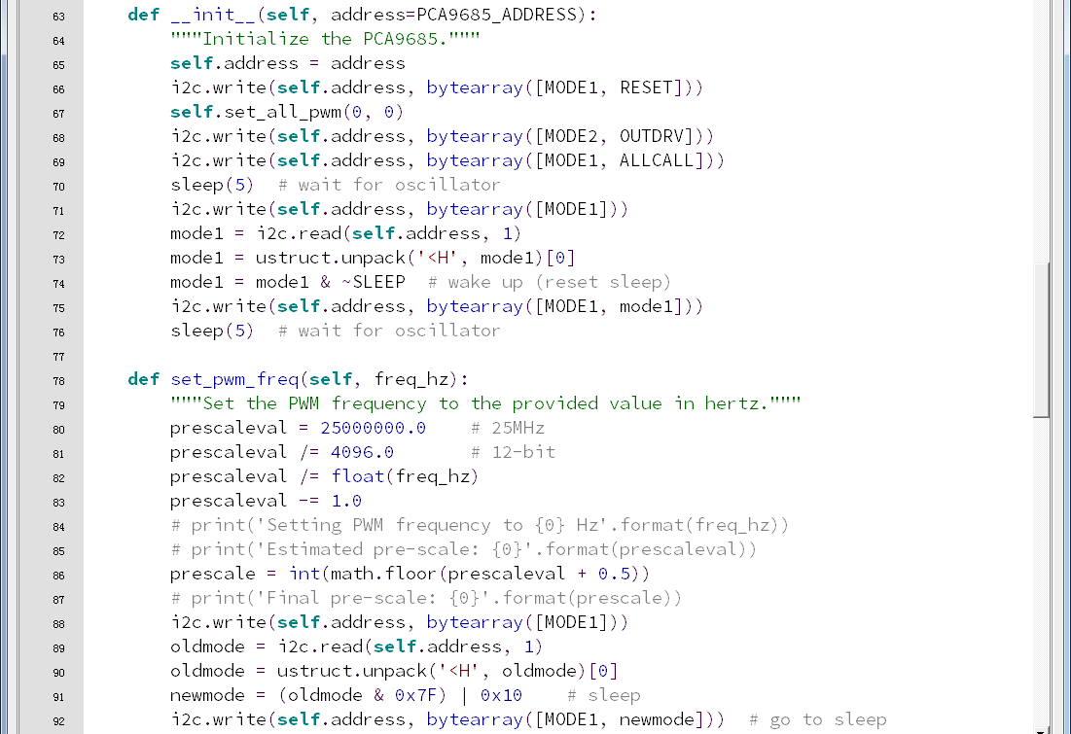
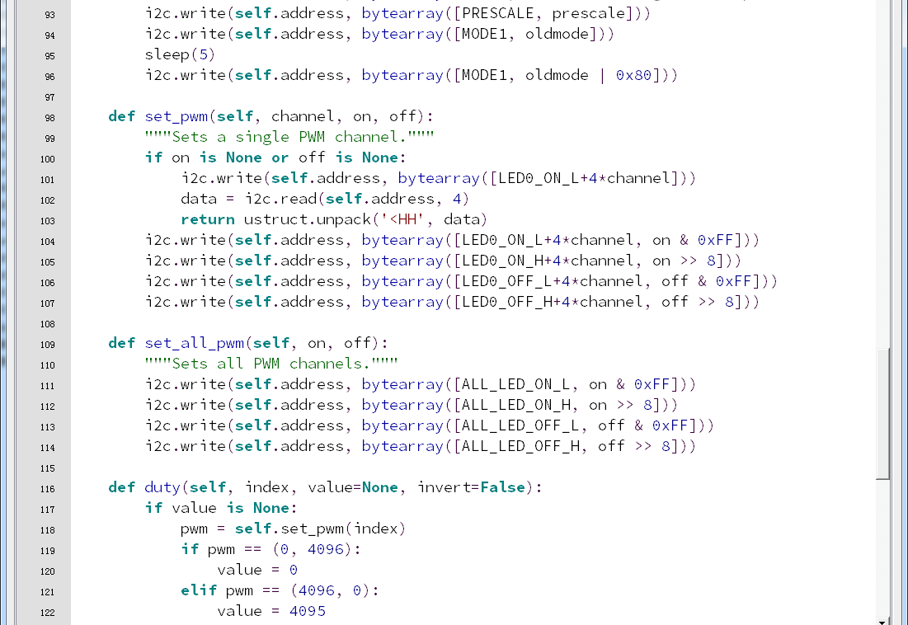
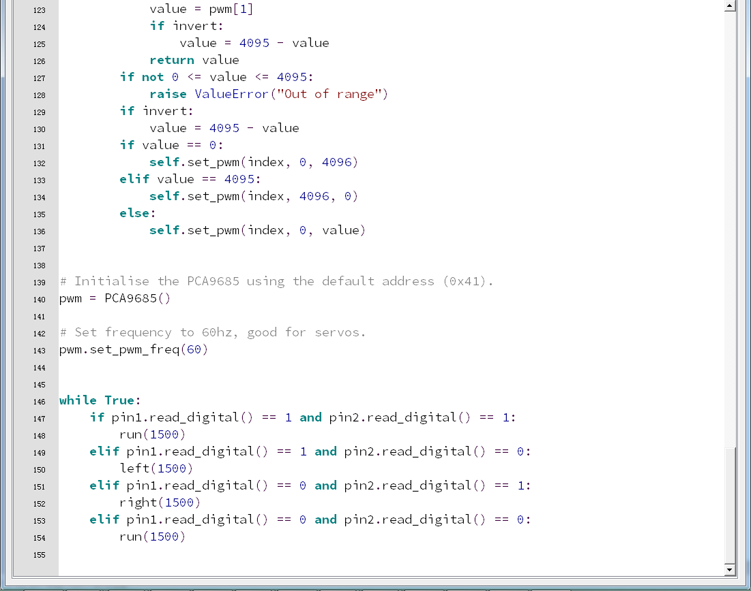
7-2-8
4.Download programming
You need to make sure that the micro:bit development board is connected to the computer. Then you should click on the download in the lower left corner as shown in 7-2-9 to download the program to micro:bit.
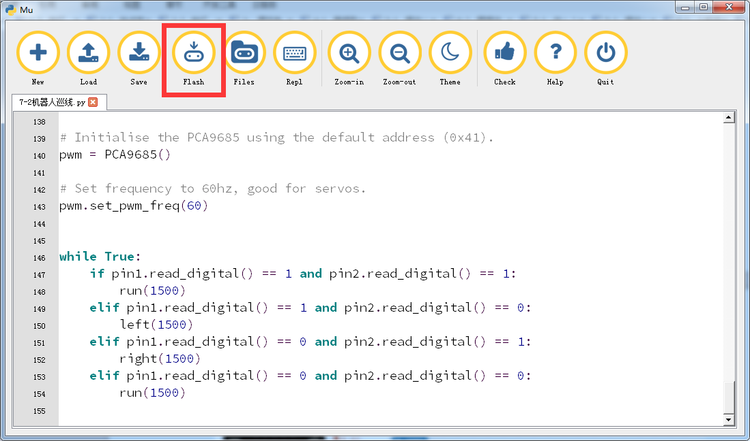
7-2-9
5.Phenomenon
After the code is uploaded. We will see that the HelloBot walk along the black line.
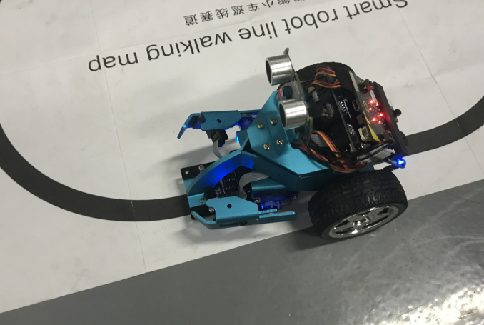
7-2-10

